Overdale Community Primary School- EYFS Spring Term 1 2025
Topic: People Who Help Us
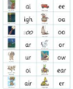Specific Area: Literacy  Our focus text for this half term will be Rosie’s hat.  We will also be reading ‘Six Dinner Sid’ and ‘Shhh.’  We will continue to recap our phase 3 sounds.  We will be reading longer words and learning how to chunk up the words to help us read them.  We will be learning new vocabulary with word aware.  We will be learning new stories in Talk For Writing and using these skills to help create our own stories.  As part of our non-fiction focus we will be creating an information text all about people who help us. |  | Specific Area: Mathematics  We will be learning about the numbers 9 and 10 in more depth and how these numbers are composed.  We will be exploring, recognizing and naming 3D shapes, thinking about their properties.  We will also be exploring 3D shapes in the environment.  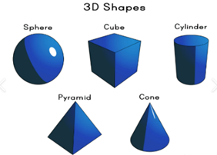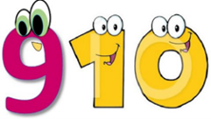
Specific Area: Knowledge and understanding of the world  In our topic ‘people who help us’ we will be talking about a variety of roles and responsibilities. We will also think about how these jobs have changed over the years.  We will also learn about Pancake Day and Scarborough’s traditions.  We will also be celebrating World Book Day.  Towards the end of the term, we will learn about the Easter story and how Easter is celebrated. | Prime Area: Communication & Language  We will be taking part in circle time games where there will be a focus on listening to the thoughts and ideas of others but also having the opportunity to offer their own ideas during group discussions.  We will begin to listen to longer stories, remembering what happens, asking relevant questions and learning new vocabulary. |  | Specific Area: Personal and Social Development  We will be working on how and why it is important to listen and follow instructions. We will also continue to think about how we keep our bodies healthy.  
Specific Area: Physical Development  In PE we will be learning about gymnastics, with a focus on our rocking and rolling skills.  We will continue with daily fine motor activities including; dough disco, scissor skills, funky fingers and name writing. |  | Specific Area: Expressive Arts & Design  We will be using our painting skills to make a community display about the people who help us which will include posters and buildings.  We will also be using our creative skills to make vehicles for people who help us using junk modelling, we will have to think about the design and use a variety of tools to help us make these.  While learning about Easter, we will also make some Easter crafts and cards.

